NATIONAL UNIVERSITY OF SCIENCES & TECHNOLOGY
School of Electrical Engineering & Computer Science (SEECS)
Parallel and Distributed Processing | HPC Project
HPC Setup & Execution
Laplace Solver
Course | Parallel and Distributed Processing
Designed by | Awais Asghar
Instructor | Dr. Attique Dawood
HPC System | NUST RCMS Supercomputer
Compute Node | compute-0-5
Date | May 2026

Overview
This document is a complete guide covering every single step required to log in, upload, compile, run, and verify the Laplace Solver project on the NUST RCMS HPC Supercomputer. Every command is written exactly as it should be typed. Nothing is skipped.

What you need | PC with WSL (Ubuntu) or a Linux machine
HPC username | awais.seecs (replace with your own username)
HPC IP address | 10.19.10.50
Head node name | afrit
Compute node used | compute-0-5
Project folder | C:\Users\DELL\OneDrive - National University of Sciences & Technology\NUST\8th Semester\Parallel and Distributed Processing\Lab Work\Project\Solution\Project
Offline nodes | compute-0-7, 14, 15, 20, 25, 29, 30 (do not use)
WARNING: Never run simulations on the head node (afrit). Always SSH into a compute node first. Any simulation on the head node will be terminated without warning and data may be lost.

Phase 1: Uploading the Project to HPC

1.1 Open Your Terminal
Open WSL (Windows Subsystem for Linux) on your Windows PC in the Project Folder, or a Linux terminal on a Linux machine. All commands in this document are typed in this terminal window.



1.2 Upload the Project Folder to HPC
Run this one command. There are 2 commands for temporary users use scp and for your own username use 2nd command.
scp -r -O -oHostKeyAlgorithms=ssh-rsa Project user2@10.19.10.50:~

rsync -avz --progress -e "ssh -p 22 -oHostKeyAlgorithms=+ssh-rsa" . awais.seecs@10.19.10.150:~/Solution

Enter your HPC password when prompted. You will see each file uploading with progress percentages:
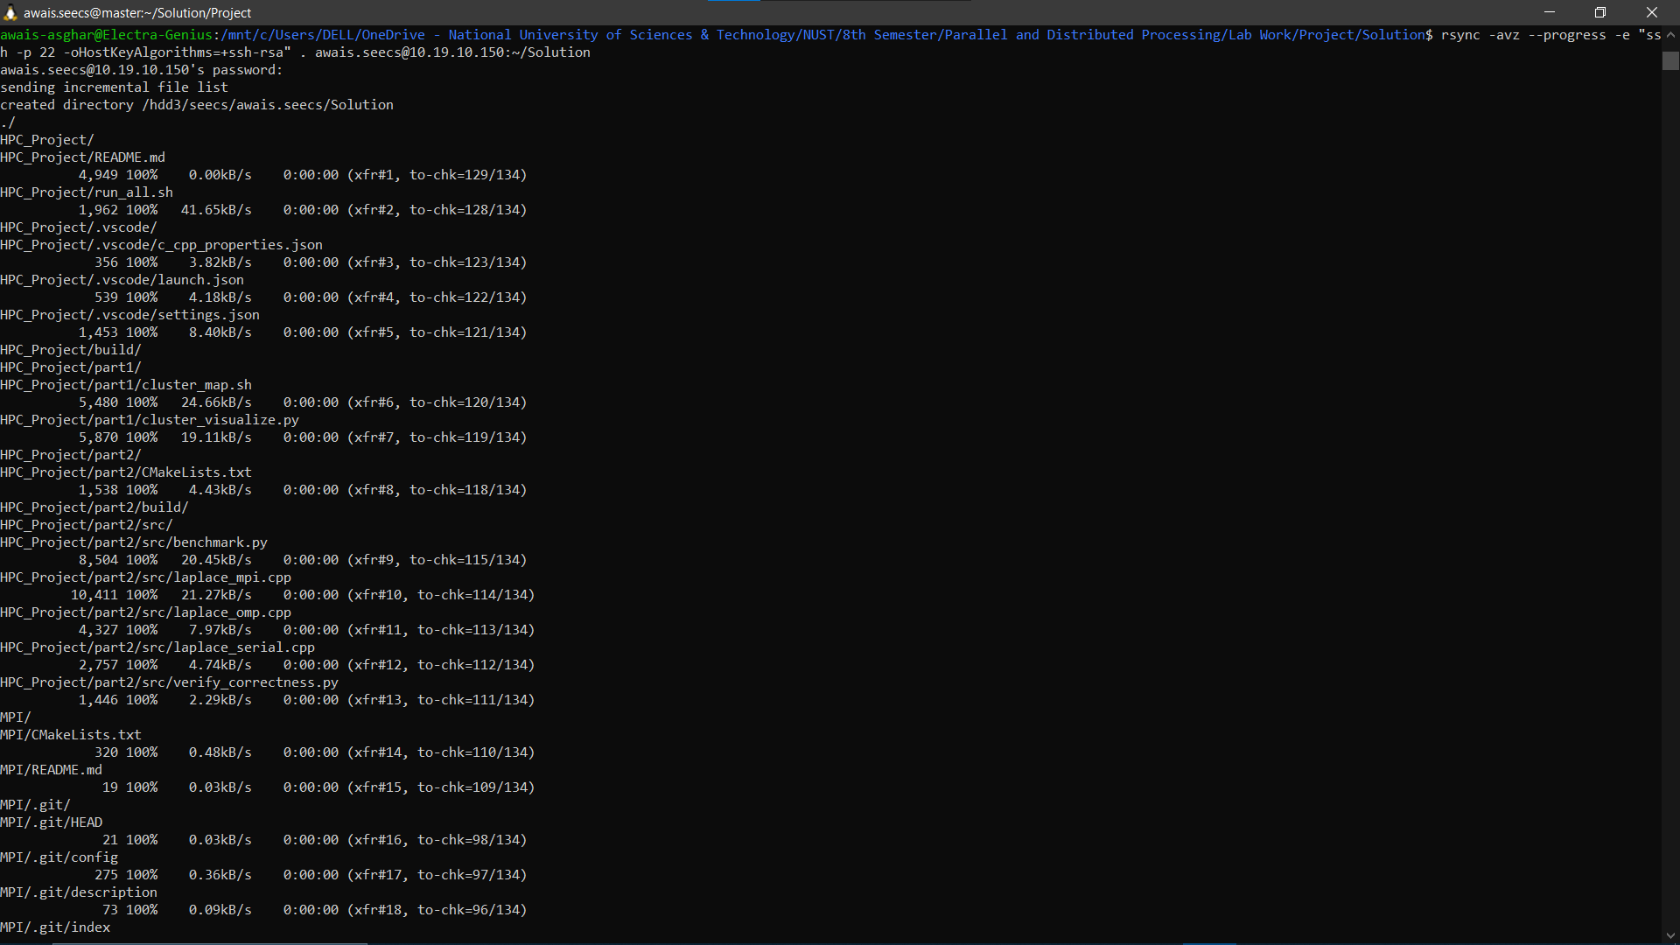

Phase 2: Again Logging Into the HPC

2.1 SSH Into the HPC Head Node
Type one of these commands according to your user type exactly to connect to the HPC. Confirm the content in your HPC using ls.
Default Username:
ssh -X user2@10.19.10.50 -oHostKeyAlgorithms=+ssh-rsa

ls
Personal Username:
ssh -X awais.seecs@10.19.10.150 -p 22 -oHostKeyAlgorithms=+ssh-rsa

ls
I am using my personal Username:
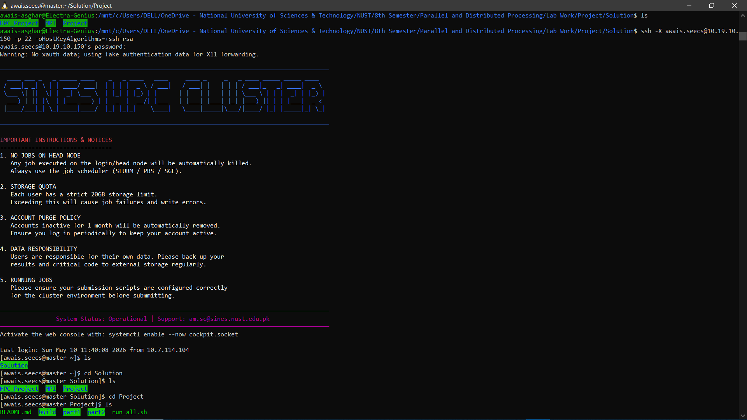

2.2 Navigate to the Build Folder

cd Solution
ls

cd Project
ls

cd part2
ls

cd build
ls

Project Folder Hierarchy:
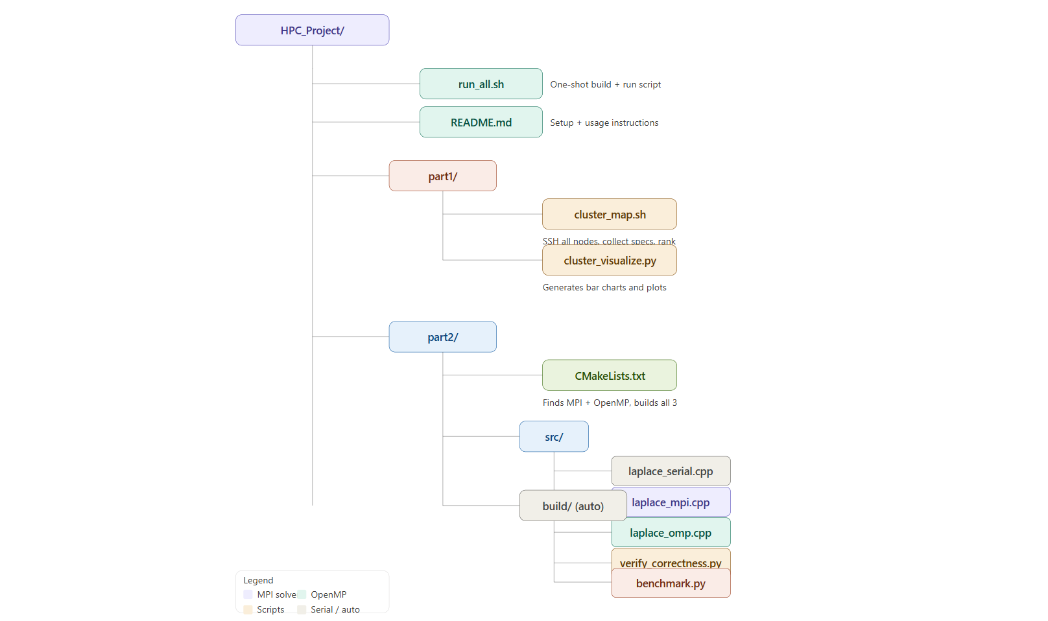
Project/

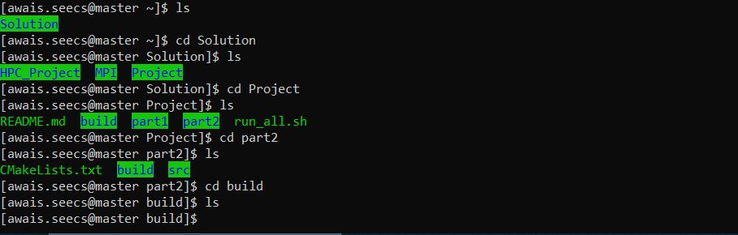

2.3 Build the project using cmake

cmake ..

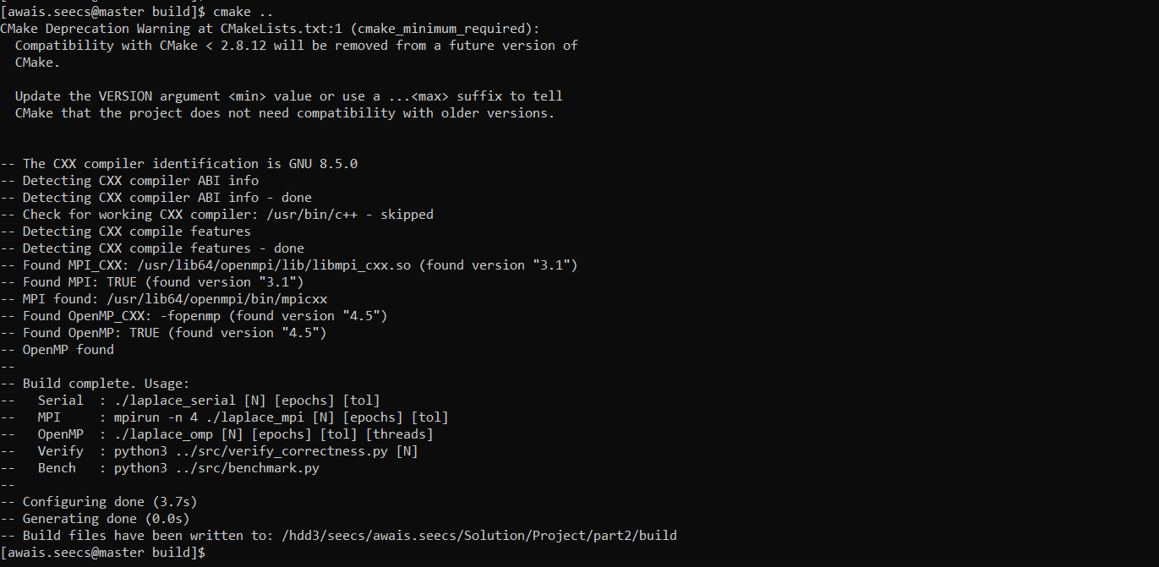

2.4 Compile All Three Solvers
make -j4

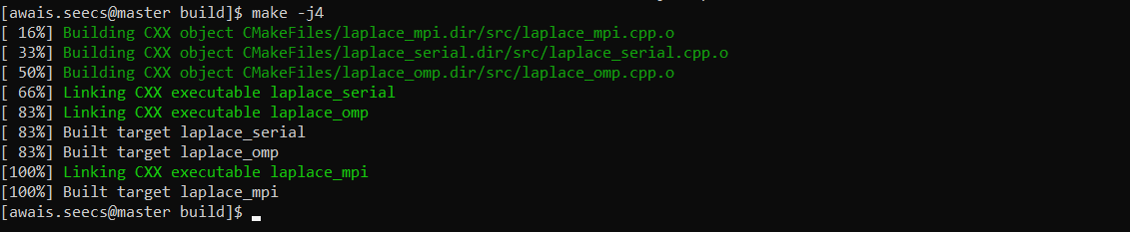

2.5 Verify Binaries Were Created
ls

Phase 3: Setting Up the Results Folder

3.1 Create the Results Directory

mkdir -p ~/Project/part2/results

3.2 Copy Binaries and Scripts Into Results
Copy all compiled binaries and Python scripts into the results folder so everything is available in one place on the compute node:

cp ./laplace_mpi ~/Project/part2/results/
cp ./laplace_omp ~/Project/part2/results/
cp ./laplace_serial ~/Project/part2/results/
cp ../src/verify_correctness.py ~/Project/part2/results/

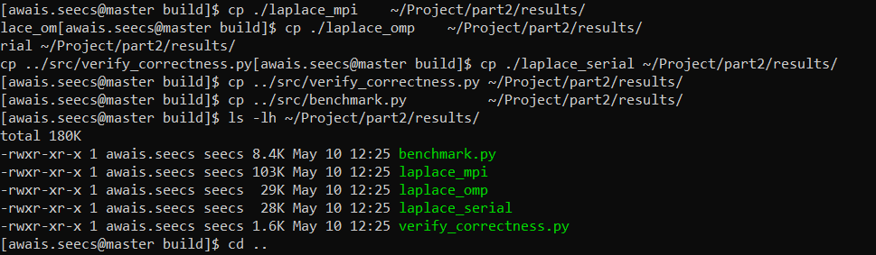

3.3 Confirm Everything Is in Place

cd ..
ls -lh ~/Project/part2/results/



3.4 SSH Into the Compute Node

Go to result folder and check the that files (benchmark.py laplace_mpi laplace_omp laplace_serial verify_correctness.py ) are visible or not. Then run the serial solver and MPI solver with 4 processes. Run the OpenMP solver using with 4 threads and run the verification script. Please check the python version on your HPC. In my case, I have a python3.

cd ~/Project/part2/results
./laplace_serial 32 10000 1e-4
mpirun -n 4 ./laplace_mpi 32 10000 1e-4
./laplace_omp 32 10000 1e-4 4
python3 verify_correctness.py 32

Phase 4: Running the Full Benchmark
Run each command one at a time. Wait for each to finish before typing the next one.

4.1 MPI Scaling Test (N=256, Varying Processes)
Tests how MPI speedup grows as we add more processes:

mpirun -n 1 ./laplace_mpi 256 5000 1e-4

mpirun -n 2 ./laplace_mpi 256 5000 1e-4

mpirun -n 4 ./laplace_mpi 256 5000 1e-4

mpirun -n 8 ./laplace_mpi 256 5000 1e-4

4.2 OpenMP Scaling Test (N=256, Varying Threads)

./laplace_omp 256 5000 1e-4 1

./laplace_omp 256 5000 1e-4 2

./laplace_omp 256 5000 1e-4 4

./laplace_omp 256 5000 1e-4 8

4.3 Serial Baseline for Different Grid Sizes

./laplace_serial 256 5000 1e-4

./laplace_serial 512 5000 1e-4

4.4 Grid Size Scaling With 4 Procs and 4 Threads
mpirun -n 4 ./laplace_mpi 128 5000 1e-4

mpirun -n 4 ./laplace_mpi 256 5000 1e-4

mpirun -n 4 ./laplace_mpi 512 5000 1e-4

./laplace_omp 128 5000 1e-4 4

./laplace_omp 256 5000 1e-4 4

./laplace_omp 512 5000 1e-4 4

Phase 5: Generating Graphs

5.1 Print the content of csv files
cat mpi_timing.csv

cat omp_timing.csv

cat serial_timing.csv

5.3 Generate All Graphs on Your PC
Install matplotlib if not already installed. Use Matplotlib to generate the png files of graphs.
pip install matplotlib numpy
Graphs you now have for the report:
speedup_comparison.png
execution_time.png
grid_scaling.png
efficiency.png
bar_comparison.png
mpi_scaling.png

Phase 6: Part I - Mapping the HPC Cluster
Part I of the project requires mapping all compute nodes, finding CPU specs, identifying busy nodes, and ranking them by availability.

6.1 SSH Back Into HPC and Go to Part 1 Folder

ssh -X awais.seecs@10.19.10.150 -p 22 -oHostKeyAlgorithms=+ssh-rsa
cd ~/Project/part1

6.2 Run the Cluster Mapping Script
This script SSHes into every compute node from compute-0-0 to compute-0-28, collects CPU model, core count, RAM usage, and system load, then ranks all nodes by availability score:

bash cluster_map.sh

This takes 2 to 4 minutes as it probes 29 nodes. Each node is checked in real time. When finished two files are created:
- cluster_report.txt - human readable ranking table
- cluster_data.csv - comma separated data for graph generation

6.3 View the Node Ranking
cat cluster_report.txt

6.4 Generate Cluster Graphs
On your PC, download the CSV and generate graphs:
node_availability.png
node_ram.png
node_cpu_specs.png
numa_architecture.png
ram_pie.png

